DSDSATSIP

Waste Reduction and Recycling Plan

2022-2025

# Introduction

The *Queensland Waste Reduction and Recycling Act 2011* (the Act)requires each State entity to prepare, adopt and implement a waste reduction and recycling plan. Each plan will contribute to achievement of the ten year state-wide targets set in the *Queensland Waste Avoidance and Resource Productivity Strategy (2014-2024)* [the Strategy]*.*

The Department of Seniors, Disability Services and Aboriginal and Torres Strait Islander Partnerships (DSDSATSIP) plan for waste reduction and recycling sets the department’s direction for waste management for three years to 2025.

DSDSATSIP will continue to identify and implement waste minimisation and recycling opportunities to ensure that it plays it’s part in achieving the Queensland Government’s objectives.

# Overview of the organisation

DSDSATSIP’s purpose is to improve the social and economic wellbeing of Aboriginal peoples, Torres Strait Islander peoples, seniors, carers and people of all abilities, by delivering quality targeted support and leading change through enhanced relationships and improved decision making.

The department contributes to the government’s objectives for the community:

* **Supporting jobs** – by facilitating new job opportunities for Aboriginal and Torres Strait Islander Queenslanders and people with disability and ensuring the opportunities of the National Disability Insurance Scheme are realised through job creation.
* **Backing small business** – by empowering Aboriginal and Torres Strait Islander -owned businesses and communities to achieve their economic aspirations and facilitating the growth of disability service providers under the NDIS.
* **Backing out frontline services**–delivering disability accommodation support and respite services and enabling people with disability to access services that assist them with their core activities of daily living.
* **Growing our regions** – helping Queensland’s regions grow by removing barriers in land administration to support home ownership and economic development in remote and discrete communities.

# What wastes are generated from DSDSATSIP activities

DSDSATSIP employs over 2,000 staff working from multiple locations across the state. Most of the waste that DSDSATSIP staff members generate is office-based and it is on this waste that the plan focuses.

However, the department generates, directly or indirectly, relatively low volumes of non-office-related waste. An example where non-office waste is generated is through its building construction activities.

A previous survey into the office-based waste stream indicated that it is consistent with the profile of waste generated in a typical office environment, as represented in Figure 1.

Figure 1 - Components of a typical office-based waste stream - Paper 49%, co-mingled recycling 21%, organics 17%, landfill (non-recyclable) 10%, cardboard 3%

**Figure 1: Components of a typical office-based waste stream**

# DSDSATSIP approach to waste management

In line with the objectives of the Act, DSDSATSIP is committed to avoiding unnecessary consumption and waste generation – where possible and appropriate, adopting innovative resource recovery approaches, and managing all products and materials as valuable and finite resources.

Our approach to waste management is informed by principles stated in the Act and reflected in the lead agency’s plan on which DSDSATSIP has drawn heavily in developing its plan.

# The waste management hierarchy

The waste and resource management hierarchy (Figure 2 below) sets the order of preference for options to manage waste—from avoiding, to re-using, recovering, treating and disposing of waste.

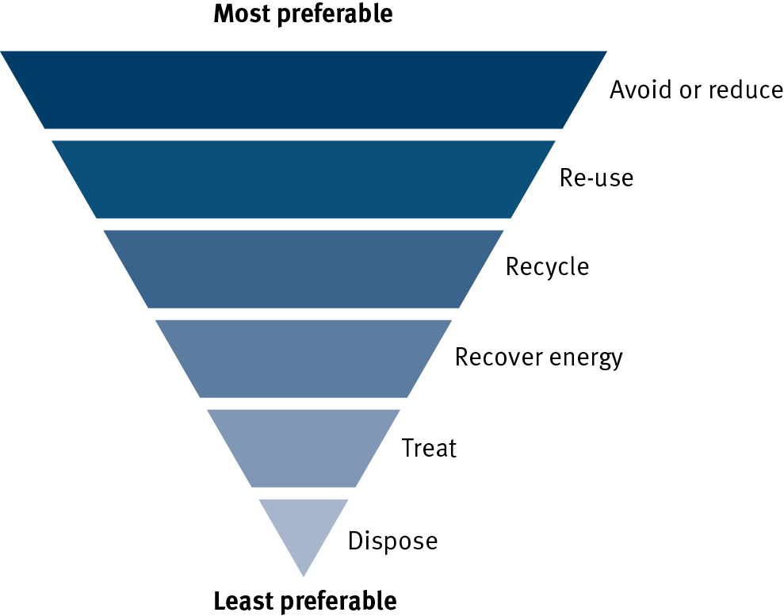

Figure 2: The waste and resource management hierarchy

The hierarchy is a tool to help decision makers prioritise waste management activities. Where avoidance is not possible, options should be investigated for the reuse, and then recycling of waste materials. As the next available option, waste could be used as a source of energy. Disposal of waste should be the last resort.

The table below details how DSDSATSIP will use the hierarchy in managing its waste.

|  |  |  |
| --- | --- | --- |
| Management option | Definition | Examples of activities that could be applied by staff across the department |
| Avoid | Avoid unnecessary resource consumption | Avoid the generation of paper waste by encouraging the increased use of digital mobile technologies to enable access to information in electronic formats and using electronic copies (not hardcopies) of documentation. |
| Reduce | Reduce waste generation and disposal | Ensure all printers are set to double-sided printing as a default.  Buy in bulk to reduce volume of paper and plastic packaging.  Reduce the requirement (where appropriate) for hardcopy filing of departmental records through use of an electronic document and records management system (EDRMS). |
| Reuse | Reuse waste resources without further manufacturing | Review policies on the disposal of obsolete ICT (or other) equipment with a focus on identifying alternative uses or users. |
| Recycle | Turning waste resources into similar or different products | Increase staff awareness in order to maximise recycling and avoid contamination of recycling bins. |
| Disposal | Dispose of waste only if there is no viable alternative | Ensure that our waste will only be disposed of at landfill facilities that are operated in accordance with prescribed legislation |

# Resource management principles

The following principles will guide the decisions we make in the management of our waste.

|  |  |  |
| --- | --- | --- |
| Principle | Definition | Examples of activities that could be included in action plans |
| The polluter pays principle | All costs associated with the management of waste should be borne by the persons who generated the waste. The costs associated with the management of waste may include the costs of minimising the amount of waste generated, containing, treating and disposing of waste, and rectifying environmental harm caused by waste. | Educating staff on the full implications of inappropriate waste activities – e.g. once a co-mingled recycling bin is contaminated, the contents of the whole bin will go to landfill. This has an environmental cost as well as an added financial cost to the organisation. |
| The proximity principle | Waste and recovered resources should be managed as close to the source of generation as possible. | Reviewing waste management arrangements to ensure that we use local service providers where possible.  (Note: This will be particularly relevant to the management of waste in regional and remote locations.) |
| The product stewardship principle | There is a shared responsibility between all persons who are involved in the life cycle of a product for managing the environmental, social and economic impact of the product. | Reviewing procurement procedures. |

# Continuous improvement

The continuous improvement steps identified below reflects the department’s strategic approach to improving how it manages its waste. DSDSATSIP will encourage staff to understand and embrace the financial and environmental benefits of applying good waste reduction and recycling practices.

Staff are actively encouraged to foster best practice in waste management and to contribute ideas and innovative approaches so that we continue to improve on our achievements to date.

[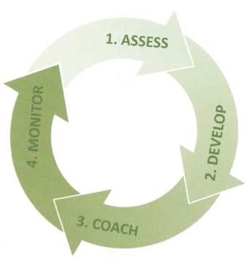](http://www.google.com.au/url?sa=i&rct=j&q=&esrc=s&frm=1&source=images&cd=&cad=rja&uact=8&ved=0CAcQjRxqFQoTCOj02eLT0scCFQbipgodk_UB5A&url=http%3A%2F%2Fwww.ussaglobal.com%2Fcore-services%2Fintegrated-management-systems%2F&ei=6u7jVejXMYbEmwWT64egDg&psig=AFQjCNHgT-VNIzJxs94YlvPKZFYw_7IHUg&ust=1441087401122989)

# Long-term objectives

Waste—Everyone’s responsibility: Queensland Waste Avoidance and Resource Productivity Strategy (2014–2024) sets a range of targets to be achieved by 2024.

By adopting best practice waste management and reduction practices over the life of this plan and into the future, and in accordance with targets set in the Strategy, the department’s objective is to maximise its contribution to achieving state targets, within the context of the wider public interest.

Through the implementation and application of this plan, DSDSATSIP will contribute to achieving a five per cent p.a. reduction (from 2012-2013 levels) as identified by the former Department of Environment and Heritage Protection in the production of general waste.

In addition, the Strategy states that the Queensland Government will work with industry and the community to identify problem or priority wastes and determine the most appropriate management option for each waste stream. Action plans developed under the Strategy will include methods for the improved management of Queensland’s priority wastes.

For its part, DSDSATSIP will identify and manage waste in accordance with future state-wide action plans.

# Activities planned for the period of this report

An important objective of the 2022-2025 waste plan is to maximise the department’s contribution to achieving the state-wide strategy’s waste reduction and management targets. In doing this, we will strive toward best practice waste management and reduction practices most relevant to DSDSATSIP’s waste profile and operating environment.

While this plan outlines the department’s strategic approach to waste management, and identifies initiatives, practices and activities, which when implemented will guide departmental staff, it will be the responsibility of employees and management to action initiatives at a local level and develop tailored responses in consideration of ‘local’ issues.

The activities that the department will undertake during the time period of this plan are as follows.

# Policies and procedures

Property Services will engage with other business areas of the department to ensure that departmental operating policies and procedures take account of requirements of related Queensland Government waste management legislation, strategies and plans.

# Resource materials

Property Serviceswill engage with the department’s Communications team in the development of resource and promotional materials to be deployed as part of a broader communication plan.

It is envisaged that the material will include a “What can I do” sheet that identifies practices and opportunities in office waste reduction and recycling, and other promotional materials tailored to departmental offices across the state.

These resources will be regularly reviewed and provided to all employees (via intranet news bulletins). This will incorporate initiatives and new developments in waste management as they present.

# Waste management communication plan

Property Services will engage with the department’s Communications team to develop and manage a communication strategy that promotes and provides information about contemporary waste management and minimisation practices.

# Performance assessment

The department’s performance in waste management will be assessed against the successful completion / implementation of the activities committed to in this plan.

Although not proposing to undertake detailed measurement of waste produced across the department or by targeted offices the department will participate in any waste assessment activity appropriate to the department’s circumstances that may be required by Government.

# Waste reduction and recycling targets

The Waste Reduction and Recycling Act 2011 requires each agency to meet waste reduction and recycling targets for the waste generated by the department in carrying out its activities.

# Waste generation target

In line with the state-wide reduction target for all general waste, DSDSATSIP will strive towards best practice, relevant to each of its sites, as a means of contributing towards the whole-of-government reduction targets for reducing state-wide waste generation.

# Recycling target

In line with the state-wide target for commercial and industrial waste, DSDSATSIP will work towards best recycling practice (as relevant to individual locations) by increasing staff awareness as a means of contributing towards a state-wide recycling rate of 55 per cent in the commercial and industrial waste stream by 2024.

# Roles and responsibilities

## Director-General

The Director-General is the ‘accountable officer’ and has ultimate responsible for:

* approving the department’s waste reduction and recycling activities and ensuring that a waste plan is developed and implemented
* ensuring that the department meets its reporting requirements

## Business area management (regional directors, executive directors, directors and managers)

These officers are responsible for ensuring that waste reduction practices are implemented and reviewed in accordance with the requirements of this and supporting plans.

## Director Property Services

The Director, Property Services is responsible for:

* developing and implementing the waste plan
* managing, monitoring, coordinating and evaluating departmental waste management initiatives to ensure that the department contributes toward meeting waste reduction and recycling policy requirements
* reporting on activities related to waste reduction and recycling policy requirements
* providing the central contact point for expert advice and assistance to departmental officers and to supplier organisations on all aspects of waste reduction and recycling

## Employees

Under the Queensland Government Code of Conduct, all employees are required to give effect to official public sector priorities, policies and decisions. In relation to this plan, employees are required to:

* apply waste reduction practices in accordance with the department’s waste reduction and recycling plan and whole-of-government strategy
* act to minimise or prevent waste
* participate in identifying and recommending waste reduction and recycling initiates

# Reporting

To meet state waste management legislative obligations, DSDSATSIP will report annually to the Department of Environment and Science (DES) on its progress. The form that the report takes will be determined by DES and will be aligned to the requirements of the Waste Reduction and Recycling Act 2011.

# Glossary of terms

**Avoidance:** Is simply avoiding the production of waste. It is often associated with the terms ‘waste reduction’ and ‘waste minimisation’.

**Best practice:** A [method](http://www.businessdictionary.com/definition/method.html) or [technique](http://www.businessdictionary.com/definition/technique.html) that has consistently shown [results](http://www.businessdictionary.com/definition/result.html) superior to those achieved with other [means](http://www.businessdictionary.com/definition/mean.html), and that is used as a [benchmark](http://www.businessdictionary.com/definition/benchmark.html).

**General waste:** Waste that is not a ‘regulated waste’ under Schedule 7 – Environmental Protection Regulation 2008. (everyday waste requiring no treatment and sent to landfill).

**Minimisation:** See ‘Reduction’

**Priority wastes:** Wastes with high disposal impacts (such as toxicity or greenhouse gas emissions), social impacts (such as community concern or amenity), or whose recovery would present resource savings or business opportunities.

**Recycling:** Recycling is a process whereby waste material is collected, sorted, reprocessed or re-manufactured in order to make a new product

**Reduction:** A process of elimination that involves reducing the amount of waste produced.

**Resource recovery:** The extraction of useful materials or energy from solid waste.

**Reuse:** The practice of reapplying a substance to its original or different use

**Waste/s:** includes:

* + Any substance (whether solid, liquid or gaseous) that is discharged, emitted or deposited in the environment in such a volume, constituency or manner as to cause an alteration in the environment
  + Any discharged, rejected, unwanted, surplus or abandoned substance
  + Any otherwise discarded, rejected, unwanted surplus, or abandoned substance intended for sale or recycling, reprocessing, recovery or purification by a separate operation from that which produced the substance
  + Any substance prescribed by the regulations to be a waste. A substance is not precluded from being a waste merely because it can be reprocessed, re-used or recycled.