Factsheet 1

Why is co-design important?

What is co-design?
Co-design is the active involvement of people with disability in decision making processes across policy, legislation, services, and products.
Co-design is inclusive. It brings together government agencies, industry, business, community organisations, people with disability and their families and supporters around issues or opportunities.
Co-design is an inclusive process of collaboration in which a diverse group of people with relevant skills, experience or interests come together to share expertise and make decisions on a piece of work.
Working together in this way is a better way to get things done and ensure solutions from different perspectives are shared to ensure more peoples’ needs are considered. Co-design means working ‘with’ people with disability, not ‘to’ them. Results are more appropriate and user-friendly.
Co-design should go beyond disability-specific issues. People living with disability use mainstream services and facilities and are affected by laws and policies that apply to everyone. People with disability need to be involved in disability-specific decisions, but also decisions that affect the wider community.

The engagement spectrum
Engagement activities vary according to the level of influence that community members have on the process.
The engagement spectrum below can be used to understand and express the level you are working at.
When you are planning engagement:
- identify the level of influence people with disability could have
- ensure people are informed about the level of influence they will have
- be open to increasing the level of influence, if people with disability identify opportunities for better outcomes.
 | Inform | Consult | Involve | Collaborate | Empower
Stakeholder Participation Goal | Researchers provide stakeholders with balanced and objective information to assist them in understanding the research. | Researchers obtain stakeholder feedback on the research. | Researchers work directly with stakeholders to ensure that stakeholder concerns and aspirations are consistently understood and considered in the research. | Researchers partner with stakeholders for salient aspects of the research. | Researchers assist stakeholders in conducting their own research.
Promise made to stakeholders by researchers | We will keep you informed. | We will keep you informed, listen to and acknowledge your concerns and aspirations and provide feedback on how your input influenced the research. | We will keep you informed, listen to and acknowledge your concerns and aspirations and provide feedback on how your input influenced the research. | We will look to you for advice and innovation in designing and conducting the research and incorporate your advice and recommendations to the maximum extent possible. | We will provide advice and assistance as requested in line with your decisions for designing and conducting your research, as well as for implementing the findings.
(Credit: adapted from the International Association of Public Participation (IAP2) Engagement Spectrum)

Principles of co-design
Meaningful co-design:
- begins early and continues for the life of an activity or project
- includes people with different experiences of disability, and other aspects of diversity (such as age, gender and sexual identity, location, cultural background and language)
- ensures the process is guided by principles.
Queenslanders with Disability Network has developed the following principles for co-designing with people with disability:

Authentic voice
The voice of people with disability is present, strong, included, and valued as part of the co-design process.

Respect
The co-design process respects people with disability, valuing individual capacity and diversity.

Rights
Co-design is underpinned by human rights and needs.

Resilience
People with disability co-design ideas and solutions to lead and influence change and are here for the long term.

Collective action
Good co-design brings people to work together in a way that enables everyone to bring different experiences, values, and wisdom to the table.
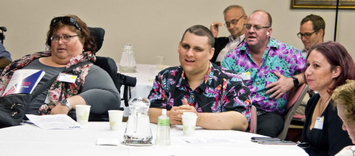
Image caption: A photograph of people sitting at a table inside a room.

