Truth-telling and Healing Inquiry and First Nations Treaty Institute
Stakeholder Pack

Current as at 30 November 2023

Table of contents
Page
1 Who this pack is for 2
2 About truth-telling and healing 2
3 Truth-telling and Healing Inquiry and First Nations Treaty Institute 4
4 Key messages 7
5 Standard email response 9
6 Social media posts 11
7 Frequently asked questions – Truth-telling and Healing Inquiry 14
8 Frequently asked questions – First Nations Treaty Institute 17
9 Frequently asked questions – Path to Treaty 19

Acknowledgement of Country
We pay our respects to the Aboriginal peoples and Torres Strait Islander peoples of this land, their spirits and their legacy. The foundations laid by these ancestors — the First Australians — give strength, inspiration, and courage to the current and future generations, towards creating a better Queensland.
We recognise it is our collective efforts and responsibility as individuals, communities, and governments to ensure equality, recognition, and advancement of Aboriginal and Torres Strait Islander Queenslanders across all aspects of society and everyday life are realised.
We are committed to working with, representing, advocating for
and promoting the needs of Aboriginal and Torres Strait Islander Queenslanders with unwavering determination, passion, and persistence.
As we reflect on the past and give hope for the future, we walk together on a shared journey of reconciliation where all Queenslanders are equal and the diversity of Aboriginal and Torres Strait Islander cultures and communities across Queensland are fully recognised, respected, and valued by all Queenslanders.

Who this pack is for
This stakeholder pack has been created for anyone who may be approached for information, or with questions, about the Truth-telling and Healing Inquiry (the Inquiry) and the First Nations Treaty Institute (Treaty Institute).
This includes Regional Directors, Government Treaty Readiness Committee members, the Path to Treaty Office, the Communications team from the Department of Treaty, Aboriginal and Torres Strait Islander Partnerships, Communities and the Arts, the Interim Truth and Treaty Body (ITTB), and other stakeholders internal and external to Government.
This pack gives an overview of truth-telling and healing, the Inquiry and Treaty Institute, key messages, standard responses and frequently asked questions.

About truth-telling and healing
The Queensland Government is committed to progressing the Path to Treaty with Aboriginal peoples and Torres Strait Islander peoples.
Any treaty must be based on truth. The truth about our past will help Queenslanders understand how modern Queensland came to be, but it may be difficult and traumatic. That is why truth-telling must be combined with healing.
Queenslanders have told us that they wish to hear and record the history of our state through a truth-telling and healing process. Hearing the truth about our shared histories helps us to understand how past laws, policies and practices have, and continue to, impact Aboriginal peoples and Torres Strait Islander peoples.
It also helps us to heal. It is an important step on the Path to Treaty.
A report by the Treaty Advancement Committee recommended a two-stage approach to truth-telling and healing:
- local truth-telling and healing activities working with our public institutions – for example, the Queensland State Library, museums, Queensland State Archives, and art galleries. This is underway, led by the Interim Truth and Treaty Body (ITTB). The ITTB is independent of government and one of its roles is to co-design and guide preparations for Queensland’s truth-telling and healing process. Find out more at www.truthandtreatyqld.org.au.
- a formal Truth-telling and Healing Inquiry set up under legislation for a period of three years, unless extended.
The Committee also recommended creating an independent First Nations Treaty Institute to support Aboriginal and Torres Strait Islander peoples to become treaty-ready and to lead a truth-telling and healing process for Queensland.
Truth-telling as part of the Path to Treaty
Queensland’s truth-telling and healing process will be guided by the ITTB and a formal Truth-telling and Healing Inquiry.
The Queensland Government set up the ITTB to work with community to support treaty readiness and local truth-telling before the establishment of the First Nations Treaty Institute.
The Truth-telling and Healing Inquiry will build community understanding of our shared history and support the process of healing for individuals, communities, and our state.

Truth-telling and Healing Inquiry and First Nations Treaty Institute
The Path to Treaty Act 2023, passed in May 2023, provides the legislative framework enabling the Truth-telling and Healing Inquiry and the First Nations Treaty Institute to be established.
While the Act has passed, commencement will occur on proclamation, with the date yet to be determined (as of November 2023).
In the lead up to commencement of the Act and in partnership with the ITTB, planning is underway to establish the structures to deliver the Inquiry and the Institute.
The Truth-telling and Healing Inquiry (the Inquiry) will be formed of five members, including a chairperson, and run for three years, unless extended.
The Inquiry, once established, will:
- provide a public platform for Aboriginal and Torres Strait Islander peoples to share their experiences
- listen to and record the stories shared
- hold a formal inquiry into the historical and ongoing impacts of colonisation in Queensland, including previous acts of governments
- raise awareness about why the treaty process is important for a reconciled Queensland
- inform education and develop shared understandings of First Nations cultures, histories, languages, and traditions
- report the findings of the Inquiry to the Queensland Government
- make recommendations to inform treaty-making.

Truth-telling and Healing Inquiry Chair and member selection process
The Interim Truth and Treaty Body (ITTB) recommended using an Expression of Interest (EOI) process, supported by an independent assessment panel and recruitment agency, to select the Truth-telling and Healing Inquiry (the Inquiry) members and chairperson.
Here are the steps involved:
- The Inquiry will have five members, including the chairperson. One process is being undertaken to fill all positions. Applicants interested in the chairperson role do not need to submit multiple applications, however, there are additional capabilities to address.
- The EOI process has been tailored to the needs of the Inquiry and is being managed by an external recruitment agency using culturally appropriate executive search services.
- The EOI opened on 30 November 2023 and will close on 21 December 2023, with all recruitment details available via www.luminarypartners.com.au/truthtellingandhealinginquiry.
- A link to review the position descriptions and submit an EOI can also be found on the Path to Treaty website.
- Once the EOI has closed, an independent assessment panel will assess applications and make appointment recommendations.
- In accordance with advice received from the ITTB, the independent assessment panel will include both Aboriginal and Torres Strait Islander representation and be made up of people who enjoy the confidence of both Aboriginal and Torres Strait Islander peoples and communities and the Queensland Government.
- Final appointments will be made by the Governor-in-Council once the recruitment process is complete.
- The Inquiry members and chairperson will hold full-time positions for the term of the Inquiry, with the renumeration arrangements to be approved by Governor-in-Council.
The First Nations Treaty Institute (Treaty Institute) will lead preparations across Queensland to ensure First Nations communities are ready to participate in future treaty negotiations with the Queensland Government.
The Treaty Institute will be overseen by the Treaty Institute Council, which will comprise a total of 10 members: two co-chairs and eight members, all of whom will be Aboriginal and/or Torres Strait Islander people.
The Treaty Institute Council will ensure the Treaty Institute performs its important functions, which include working with community and leading development of a treaty making framework that establishes processes for future treaty negotiations.
Both the Inquiry and the Treaty Institute are expected to be established in 2024.
Treaty Institute Council member selection process
The Interim Truth and Treaty Body (ITTB) recommended using an Expression of Interest (EOI) process, supported by an independent assessment panel and recruitment agency, to select the 10 members of the Treaty Institute Council.
Here are the steps involved:
- The Treaty Institute Council will have 10 members, including two co-chairs, who will be elected after their appointment. One process is being undertaken to fill all positions.
- The EOI process has been tailored to the needs of the First Nations Treaty Institute and is being managed by an external recruitment agency using culturally appropriate executive search services.
- The EOI opened on 30 November 2023 and will close on 21 December 2023, with all recruitment details available via www.luminarypartners.com.au/firstnationstreatyinstitute.
- A link to review the position descriptions and submit an EOI can also be found on the Path to Treaty website.
- Once the EOI has closed, an independent assessment panel will assess applications and make appointment recommendations.
- In accordance with advice received from the ITTB, the independent assessment panel will include both Aboriginal and Torres Strait Islander representation and be made up of people who enjoy the confidence of both Aboriginal and Torres Strait Islander peoples and communities and the Queensland Government.
- Final appointments will be made by the Governor-in-Council once the recruitment process is complete.
- Treaty Institute Council members will hold part-time positions for two years, with the renumeration arrangements to be approved by Governor-in-Council.

Key messages
- We’ve listened to Queenslanders’ views that truth-telling must come before treaty.
- Telling the truth about our past and accepting our shared histories is where healing for Queensland begins.
- Learning the truth about our past will help Queenslanders understand how modern Queensland came to be, but it may be difficult and traumatic. That is why truth-telling must be combined with healing.
- Queensland’s truth-telling and healing process will be guided by the Interim Truth and Treaty Body and a formal Truth-telling and Healing Inquiry.
- The Path to Treaty Act 2023 establishes the legislative framework enabling the Truth-telling and Healing Inquiry and the First Nations Treaty Institute. A number of steps are being undertaken in the lead up to commencement of the Act.
- A formal Truth-telling and Healing Inquiry will be set up for a period of three years, unless extended.
- The Inquiry, once established, will:
  - provide a public platform for Aboriginal and Torres Strait Islander peoples to share their experiences
  - listen to and record the stories shared
  - hold a formal inquiry into the historical and ongoing impacts of colonisation in Queensland, including previous acts of governments
  - raise awareness about why the treaty process is important for a reconciled Queensland
  - inform education and develop shared understandings of First Nations cultures, histories, languages, and traditions.
- The Inquiry will have five members, including the Chairperson, and is expected to be established in 2024.
- The Treaty Institute will lead preparations across Queensland to ensure First Nations communities are ready to participate in future treaty negotiations with the Queensland Government.
- The Treaty Institute Council will oversee the Treaty Institute and comprise of 10 members.
- On 30 November 2023, a process will commence to select the Truth-telling and Healing Inquiry members and a chairperson, and the Treaty Institute Council members.
- A robust recruitment process, led by the Queensland Government and guided by the voices of First Nations peoples, has been established to ensure appointments to the Inquiry and the Treaty Institute Council are made in a fair manner, following a clear process.

Key messages about Path to Treaty
- Path to Treaty is a landmark reform changing Queensland’s future.
- Path to Treaty is for all Queenslanders to come together to learn, share, listen and heal as we work towards becoming treaty ready.
- A treaty is a negotiated agreement between two (or more) parties. It is only signed when all parties agree.
- In Queensland, treaty is about the Queensland Government and Aboriginal peoples and Torres Strait Islander peoples coming together, as equals, to write our future together. It may result in one treaty or multiple treaties. The process will be informed by each step along the way and is likely to take many years.
- A treaty or treaties will set the foundation for a shared future between Aboriginal peoples and Torres Strait Islander peoples and the Queensland Government, where all parties come together and negotiate a new way of working, to create positive relationships.
- The Queensland Government is committed to listening to all Queenslanders, working together, and taking the time needed to get this right.
- We encourage all Queenslanders to join the Path to Treaty. Visit www.qld.gov.au/treaty.
- Get involved with Path to Treaty – sign up for Treaty News and connect with us on social media. Follow:
Deadly Stories Facebook
Deadly Stories Instagram
LinkedIn

Standard email response
Below is a suggested email response to enquiries about the Truth-telling and Healing Inquiry and the First Nations Treaty Institute.

Dear <Insert name>,
Thank you for getting in touch.
I have included below some information about the Path to Treaty, Truth-telling and Healing Inquiry and First Nations Treaty Institute.
Queenslanders are on a Path to Treaty

The Queensland Government is committed to progressing the Path to Treaty with Aboriginal peoples and Torres Strait Islander peoples. Path to Treaty is for all Queenslanders to come together to learn, share, listen and heal as we work towards becoming treaty ready.

Any treaty must be based on truth. The truth about our past will help Queenslanders understand how modern Queensland came to be, but it may be difficult and traumatic. That is why truth-telling must be combined with healing.

About the Truth-telling and Healing Inquiry

The Truth-telling and Healing Inquiry (the Inquiry) will help build community understanding of our shared history and support the process of healing for individuals, communities, and our state.

Telling the truth about our past and accepting our shared histories is where healing for Queensland begins. This is a significant step on our Path to Treaty – we encourage all Queenslanders to participate as we understand our shared history.

The Inquiry is expected to be established in 2024 for a period of three years, unless extended.

About the First Nations Treaty Institute

The First Nations Treaty Institute (Treaty Institute) will lead preparations across Queensland to ensure Aboriginal and Torres Strait Islander peoples and communities are ready to participate in future treaty negotiations with the Queensland Government.

It will be overseen by the Treaty Institute Council, which will ensure the Treaty Institute performs its important functions, including working with community and leading development of a treaty making framework.

The Treaty Institute Council will comprise of 10 members and is expected to be established in 2024.

Expressions of Interest for Truth-telling and Healing Inquiry and Treaty Institute Council members [include if relevant to enquiry]

An Expression of Interest (EOI) process is open to interested persons for the Truth-telling and Healing Inquiry member and chairperson roles, as well as Treaty Institute Council members.
The EOIs will close on 21 December 2023. For more information, please visit:
www.luminarypartners.com.au/truthtellingandhealinginquiry
www.luminarypartners.com.au/firstnationstreatyinstitute

[Optional – insert relevant response here from FAQs, to address specific enquiry]

More information
Learn about Queensland’s Path to Treaty, visit www.qld.gov.au/treaty.
Information on support services can be found on the Queensland Government website.

Yours sincerely,
<Insert your details>

Social media posts

Truth-telling and Healing Inquiry
These images may be used in social media posts, with suggested copy noted below.
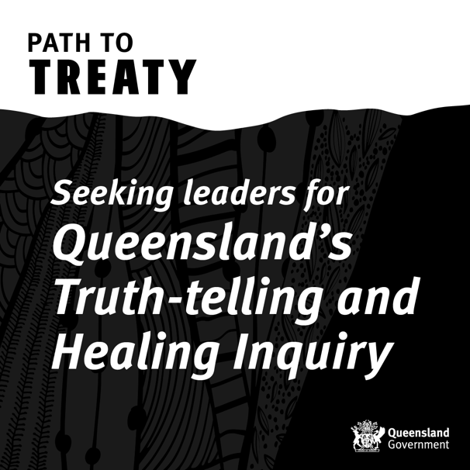
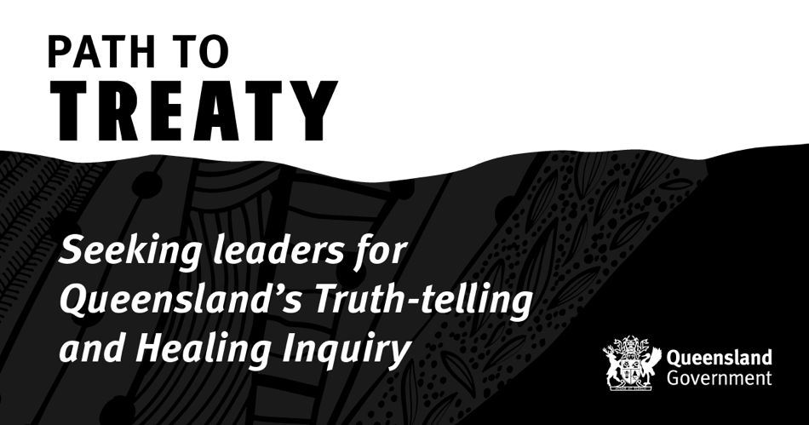

Expressions of Interest are open for members of Queensland’s landmark Truth-telling and Healing Inquiry.
As part of Queensland’s Path to Treaty, the Truth-telling and Healing Inquiry will help build community understanding of our shared history and support the process of healing for individuals, communities, and our state.
Expressions of Interest for the member and chairperson roles are now invited from those who may be able to demonstrate suitability under the selection criteria.
For more details, please visit www.luminarypartners.com.au/truthtellingandhealinginquiry.

First Nations Treaty Institute
These images may be used in social media posts, with suggested copy noted below.
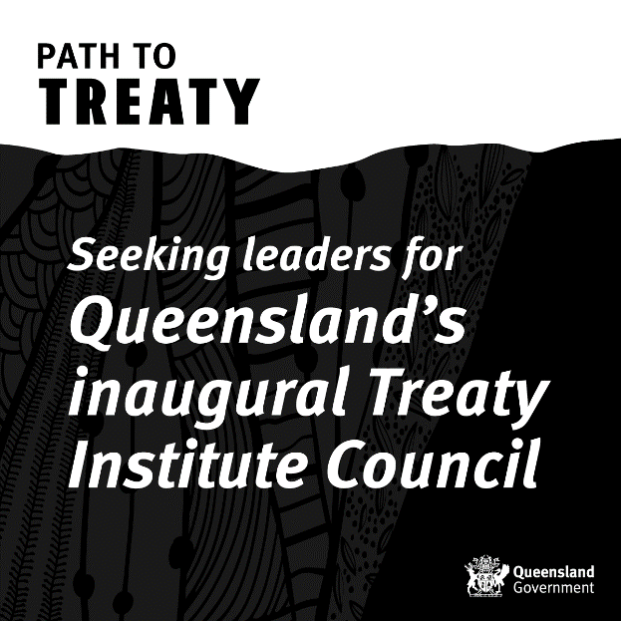
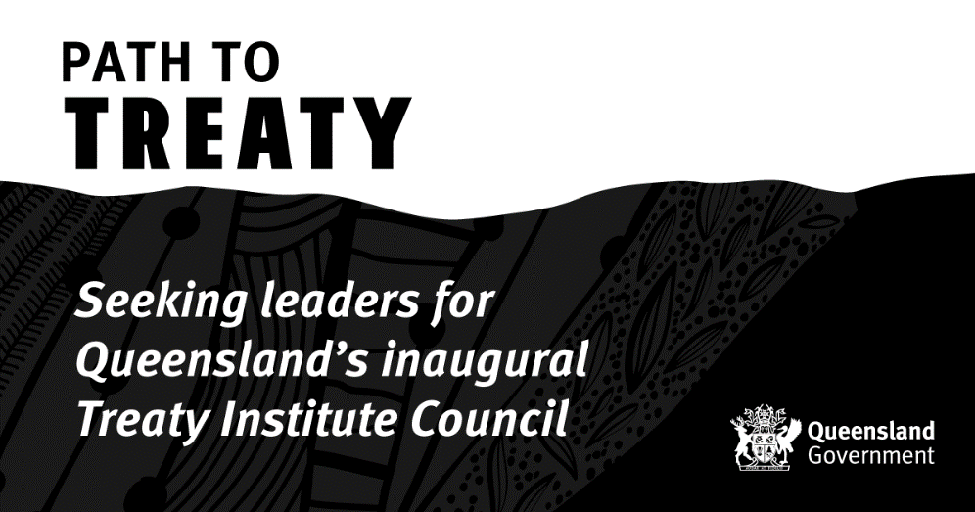
Are you an Aboriginal and/or Torres Strait Islander person with a passion for advocating for community?
Expressions of Interest are now open for members of Queensland’s inaugural Treaty Institute Council to oversee the First Nations Treaty Institute.
As part of Queensland’s Path to Treaty, the Treaty Institute will lead preparations across Queensland to ensure First Nations communities are ready to participate in future treaty negotiations with the Queensland Government.

Expressions of Interest are invited from those who may be able to demonstrate suitability under the selection criteria for the 10-member Treaty Institute Council.

For more details, please visit www.luminarypartners.com.au/firstnationstreatyinstitute.

Contact details, resources and support services
- Path to Treaty – www.qld.gov.au/treaty
- Treaty News – subscribe to the newsletter on our website.
- Interim Truth and Treaty Body – www.truthandtreatyqld.org.au
- Inquiry member recruitment – www.luminarypartners.com.au/pathtotreaty
Support services
- If you or someone you care about is at risk of harm, call Triple Zero (000) immediately.
- The Queensland Government website has more information about various mental health support services that are available.

Frequently asked questions – Truth-telling and Healing Inquiry

What is the Truth-telling and Healing Inquiry?
The Truth-telling and Healing Inquiry is a formal inquiry set up under legislation to hear and record the stories of Queenslanders about the ongoing impacts of colonisation.

Why does Queensland need a Truth-telling and Healing Inquiry?
Queenslanders have told us that they wish to hear and record the history of our state through a truth-telling and healing process. Hearing the truth about our shared histories helps us to understand how past laws, policies and practices have impacted, and continue to impact, Aboriginal peoples and Torres Strait Islander peoples. It also helps us to heal. It is an important step on the Path to Treaty.

Is the Truth-telling and Healing Inquiry part of the Path to Treaty?
Yes. Telling the truth about our past and accepting our shared histories is where healing for Queensland begins. This is a significant step on our Path to Treaty – we encourage all Queenslanders to participate as we understand our shared history.

Why is truth-telling and healing a key step on the Path to Treaty?
Any treaty must be based on truth. The truth about our past will help Queenslanders understand how modern Queensland came to be.
As part of Path to Treaty, local truth-telling will take place in the Queensland community through our public institutions, libraries, and archives. A formal Truth-telling and Healing Inquiry will also be held for a period of three years, so that we can hear and record our shared histories and truths.
It may be difficult and traumatic for all Queenslanders involved. That is why truth-telling must be combined with healing and the appropriate support.

How long will the Inquiry last?
The Inquiry will run for three years, unless extended, and will inform a way forward for Aboriginal peoples and Torres Strait Islander peoples and the Queensland Government to work together towards a future treaty or treaties.

Will the Inquiry be independent of government?
It will be a formal inquiry and Inquiry members will act independently to provide a public platform to listen and record stories, educate and build understanding about First Nations history and cultures, and make recommendations to inform future treaty-making.

How will the Expressions of Interest (EOI) work for Inquiry members?

The EOI process has been tailored to the needs of the Truth-telling and Healing Inquiry and is being managed by an external recruitment agency using culturally appropriate executive search services. The EOI opened on 30 November 2023 and will close on 21 December 2023.

Who can submit an Expression of Interest (EOI) to be on the Truth-telling and Healing Inquiry?
Expressions of Interest are invited from those who may be able to demonstrate suitability under the selection criteria. More detail about the selection criteria and the EOI is available via www.luminarypartners.com.au/truthtellingandhealinginquiry.
The Inquiry is required to have five members who reflect the gender diversity of Queensland and who are majority First Nations people, with at least one Aboriginal person and at least one Torres Strait Islander person. At least one member must be a lawyer of at least five years’ standing with experience relevant to the functions of the Inquiry.

How will the Inquiry members selection process work?
Here are the steps involved:
- The Inquiry will have five members, including the chairperson. One process is being undertaken to fill all positions. Applicants interested in the chairperson role do not need to submit multiple applications, however, there are additional capabilities to address.
- The EOI process has been tailored to the needs of the Inquiry and is being managed by an external recruitment agency using culturally appropriate executive search services.
- The EOI opened on 30 November 2023 and will close on 21 December 2023, with all recruitment details available via www.luminarypartners.com.au/truthtellingandhealinginquiry.
- A link to review the position descriptions and submit an EOI can also be found on the Path to Treaty website.
- Once the EOI has closed, an independent assessment panel will assess applications and make appointment recommendations.
- In accordance with advice received from the ITTB, the independent assessment panel will include both Aboriginal and Torres Strait Islander representation and be made up of people who enjoy the confidence of both Aboriginal and Torres Strait Islander peoples and communities and the Queensland Government.
- Final appointments will be made by the Governor-in-Council once the recruitment process is complete.
- The Inquiry members and chairperson will hold full-time positions for the term of the Inquiry, with the renumeration arrangements to be approved by Governor-in-Council.

Where will the Inquiry take place?
As part of Path to Treaty, local truth-telling will take place in the Queensland community through our public institutions, libraries, and archives.

The Inquiry will run for a period of three years, to hear and record our shared histories and truths.
Once the Inquiry is established, it will develop a schedule of community engagement and communicate with communities across the state.

How will people in Queensland contribute to the Inquiry?
Details for participating in the Inquiry will be developed once the Inquiry is established. The Inquiry will communicate widely to ensure all Queenslanders who want to contribute have an opportunity.

Information will be published on the Path to Treaty website as it becomes available. In addition, any interested person can register to receive Treaty News, the Path to Treaty e-newsletter, which will also be a communication channel.
What information will the Inquiry seek?
Information to record a shared and accurate history of Queensland, including about the historical and ongoing impacts of colonisation in Queensland.

Are the Inquiry and the Treaty Institute the same thing?
No. While both entities are to be established under the Path to Treaty Act 2023, the Inquiry will inquire into the impacts of colonisation while the Treaty Institute will support Aboriginal and Torres Strait Islander peoples to prepare for treaty negotiations.

The membership of the Inquiry Panel and the Treaty Institute Council will be recruited though separate processes and the entities will operate independently of each other. For more information, go to the Path to Treaty website.

What will the Inquiry do with the information it receives?
The Inquiry will listen to and record the stories shared. It will then report the findings to the Queensland Government.

Frequently asked questions – First Nations Treaty Institute

What is the First Nations Treaty Institute?

The First Nations Treaty Institute (Treaty Institute) will lead preparations across Queensland to ensure Aboriginal and Torres Strait Islander peoples are ready to participate in future treaty negotiations with the Queensland Government.

It will also lead development of a treaty making framework that establishes processes for future treaty negotiations.

The Treaty Institute will not be a party to negotiations for a treaty or act on behalf of a party in negotiations for a treaty.

Is the Treaty Institute part of the Path to Treaty?
Yes. The Treaty Institute will build and support First Nations treaty readiness and lead the development of a treaty making framework that establishes processes for future treaty negotiations.

This is a significant step on our Path to Treaty – we encourage all Queenslanders to participate as we understand our shared history.

When will the Treaty Institute be established?
The Treaty Institute is expected to be established in 2024.

Will the Treaty Institute be independent of government?
The Treaty Institute will be independent of government.

It will be overseen by a Treaty Institute Council made up of 10 members, including two co-chairs.

What is the Treaty Institute Council?
The Treaty Institute Council is the governing body of the First Nations Treaty Institute.

The Treaty Institute Council’s role is to ensure the Treaty Institute performs its functions and exercises its powers.

There will be two chairpersons, to be selected by the Treaty Institute Council once established.

How will the Expressions of Interest (EOI) work for Treaty Institute Council members?

The EOI process has been tailored to the needs of the First Nations Treaty Institute and is being managed by an external recruitment agency using culturally appropriate executive search services. The EOI opened on 30 November 2023 and will close on 21 December 2023.

Who can submit an Expression of Interest (EOI) to be on the Treaty Institute Council?
The Treaty Institute Council will comprise of 10 members, all of whom will be Aboriginal and/or Torres Strait Islander people.

Members will have cultural integrity and authority, courage and strength, impartiality and independence, and lived experience as an advocate for Aboriginal peoples and/or Torres Strait Islander peoples.

Expressions of Interest are invited from those who may be able to demonstrate suitability under the selection criteria. More detail about the selection criteria and the EOI is available via www.luminarypartners.com.au/firstnationstreatyinstitute.

How will the Treaty Institute Council member selection process work?
Here are the steps involved:
- The Treaty Institute Council will have 10 members, including two co-chairs, who will be elected after their appointment. One process is being undertaken to fill all positions.
- The EOI process has been tailored to the needs of the First Nations Treaty Institute and is being managed by an external recruitment agency using culturally appropriate executive search services.
- The EOI opened on 30 November 2023 and will close on 21 December 2023, with all recruitment details available via www.luminarypartners.com.au/firstnationstreatyinstitute.
- A link to review the position descriptions and submit an EOI can also be found on the Path to Treaty website.
- Once the EOI has closed, an independent assessment panel will assess applications and make appointment recommendations.
- In accordance with advice received from the ITTB, the independent assessment panel will include both Aboriginal and Torres Strait Islander representation and be made up of people who enjoy the confidence of both Aboriginal and Torres Strait Islander peoples and communities and the Queensland Government.
- Final appointments will be made by the Governor-in-Council once the recruitment process is complete.
- Treaty Institute Council members will hold part-time positions for two years, with the renumeration arrangements to be approved by Governor-in-Council.
Are the Truth-telling and Healing Inquiry and the Treaty Institute the same thing?
No. While both entities are to be established under the Path to Treaty Act 2023, the Inquiry will inquire into the impacts of colonisation while the Treaty Institute will support Aboriginal and Torres Strait Islander peoples to prepare for treaty negotiations.
The membership of the Inquiry Panel and the Treaty Institute Council will be recruited though separate processes and the entities will operate independently of each other. For more information, go to the Path to Treaty website.

Frequently asked questions – Path to Treaty

What is a treaty?
A treaty is a negotiated agreement between two or more parties. A treaty is developed through a negotiation process to determine what is in the treaty, within the respective powers of the negotiating parties. A treaty is only signed once all parties are in agreement.

Why does Queensland need a treaty?
A treaty or treaties will set the foundation for a shared future between Aboriginal peoples, Torres Strait Islander peoples and the Queensland Government. It will allow both parties to come together and negotiate a new way of working, setting the foundation for a positive relationship.

Path to Treaty is a shared path. By walking this path together, we are honouring generations of Aboriginal peoples and Torres Strait Islander peoples who have called for self-determination, truth-telling and agreement-making.

What is the Path to Treaty?

The Path to Treaty will ultimately achieve a treaty, or treaties, between the Queensland Government and Aboriginal and Torres Strait Islander peoples for a new and just relationship — one that celebrates the vibrant First Nations cultures and achieves tangible justice, equality, and opportunity for Aboriginal and Torres Strait Islander peoples.

The Path to Treaty journey began in 2019 with the release of the Statement of Commitment to reframe the relationship between the Queensland Government and Aboriginal peoples and Torres Strait Islander peoples.

Starting the treaty conversation, the Eminent Panel and Treaty Working Group led 24 public consultations on what a treaty or treaties might mean to all Queenslanders and made recommendations to Government on the next steps.

Building on this work, a Treaty Advancement Committee met with community, peak bodies, local and state governments, and experts in different fields to inform how to implement the next steps along the Path to Treaty. The Treaty Advancement Committee Report was formally handed over to the Queensland Government on 12 October 2021.

On 16 August 2022, the Queensland Government published its response to the Treaty Advancement Committee Report, accepting or accepting in principle all 22 recommendations to progress the Path to Treaty.

What is Queensland’s Path to Treaty commitment?
On 16 August 2022, the Queensland Government, Aboriginal peoples, Torres Strait Islander peoples, and non-Indigenous Queenslanders participated in the signing of Queensland’s Path to Treaty Commitment.

The Commitment signifies a collective pledge to be courageous and curious, to be open to hearing the truth of our state’s history, and to collaborate in readiness for negotiating treaties.

How are we getting Queensland ready for treaty?
The Path to Treaty Act 2023 creates the legislative framework to establish:
- A Truth-telling and Healing Inquiry to inquire into the continuing impacts of colonisation on Aboriginal peoples and Torres Strait Islander peoples in Queensland.
- A First Nations Treaty Institute to support Aboriginal peoples and Torres Strait Islander peoples to prepare for, and participate in, treaty negotiations with the state.

Establishing the First Nations Treaty Institute and the Truth-telling and Healing Inquiry in legislation sets the next steps of the Path to Treaty in law, with the goal of negotiating a treaty or treaties with Aboriginal peoples and Torres Strait Islander peoples.

How is the Queensland Government funding the Path to Treaty?
Queensland’s Path to Treaty Fund has been established as a major investment in reconciliation and healing. Returns from the Fund will be used to progress Queensland’s Path to Treaty.

Who is leading the Path to Treaty process now?
A Path to Treaty Office has been established to lead Queensland Government treaty readiness, work with the Interim Truth and Treaty Body (ITTB) to co-design arrangements for the First Nations Treaty Institute (Treaty Institute) and Truth-telling and Healing Inquiry (the Inquiry), and deliver public awareness activities about the importance of truth-telling, healing and treaty for Queensland.
The ITTB is a short-term, independent body that engages with the Queensland Government and communities to continue momentum while the Treaty Institute and the Inquiry are established. Priority activities included co-designing the legislation and the arrangements for setting up the Treaty Institute and the Inquiry and conducting community consultation across Queensland to capture the many voices of Queenslanders.

How does Path to Treaty fit with the outcome of the 2023 referendum?
Path to Treaty is Queensland’s shared journey between the Queensland Government, Aboriginal and Torres Strait Islander peoples and non-Indigenous peoples, with the goals of truth-telling and healing, and negotiating a treaty or treaties. It is separate and distinct from the federal referendum.

